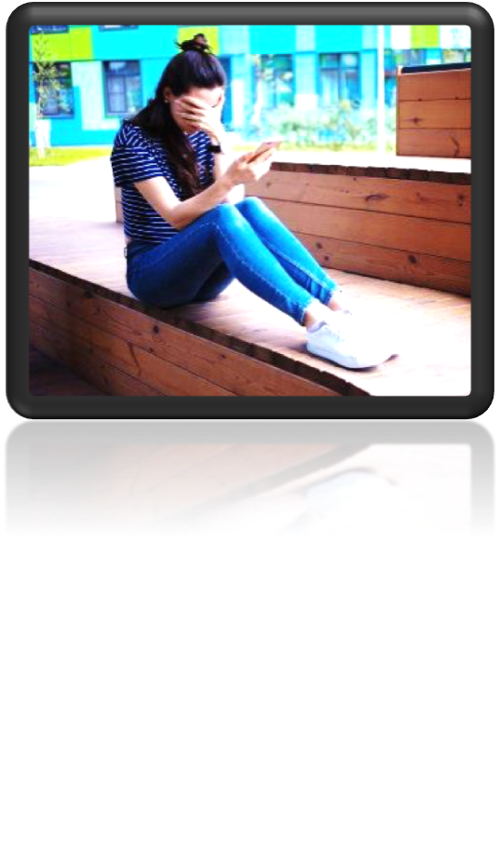

**Cyberbullying**

Cyberbullying occurs when one person uses technology to bully someone.This can happen via social media, texting, email or other apps.

**Some examples of cyberbullying:**

* Sending someone degrading, threatening or hurtful texts or emails
* Writing degrading, threatening, insulting or hurtful comments on someone’s Facebook Page
* Circulating rumors about another person on social media
* Taking an embarrassing picture of someone or altering it so it becomes embarrassing and then publishing on social media
* Making and distributing embarrassing videos of someone and publishing them without their knowledge or consent
* Hacking someone’s account and spreading inappropriate messages that they have not written

**What can you do if you are a victim of cyberbullying?**

* **Remain calm and do not answer or reply to the message you receive.**
* **Keep the message if it’s an email or text.**
* **If it’s on Facebook, take a screenshot to have proof, should you ever need it**
* **Block the person sending you these kinds of messages.**
* **Speak to an adult you trust (teacher, parent, youth facilitator). If you feel unsafe, you can call the cops.**
* **It is also possible to remove photos that have already been published by contacting this organization:** aidezmoisvp.ca**.**

**Here are additional links that can help if you have any questions regarding cyberbullying and cybersecurity.**

[https://w](http://www.teljeunes.com/Tel-jeunes/Tous-les-themes/Technos)ww.telje[unes.com/Tel-jeunes/Tous-les-themes/Technos](http://www.teljeunes.com/Tel-jeunes/Tous-les-themes/Technos) https://needhelpnow.ca/app/fr/removing_pictures-facebook [https://w](http://www.educaloi.qc.ca/jeunesse/capsules/la-cyberintimidation)ww.e[ducal](http://www.educaloi.qc.ca/jeunesse/capsules/la-cyberintimidation)oi.[qc.ca/j](http://www.educaloi.qc.ca/jeunesse/capsules/la-cyberintimidation)e[unesse/capsules/la-cyberintimidation](http://www.educaloi.qc.ca/jeunesse/capsules/la-cyberintimidation)